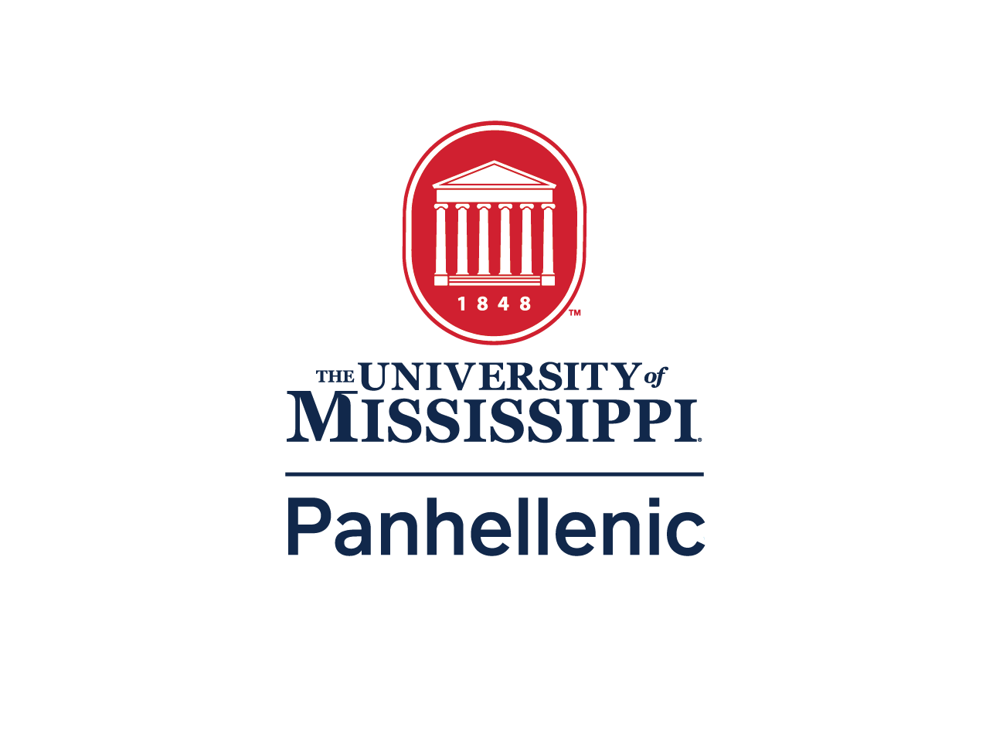

University of Mississippi College Panhellenic
2024
Standing Recruitment Rules

Updated and Approved on 04.10.24

Statement of Positive Panhellenic Contact and Promotion of the Sorority Experience
- We, the College Panhellenic members, will actively promote the overall sorority experience to potential new members, at all times, year-round, through personal and informative Panhellenic-spirited contact. We will do this through all forms of communication.
- Positive Panhellenic contact and promotion of the sorority experience does not mean creating an unfair advantage for a particular chapter. It does mean being friendly and responding to questions potential new members might ask of Panhellenic members. It does mean promoting sorority membership in general, not a particular organization. It also means current and alumnae members do not have to hide their sorority affiliation or be forced to delete social media accounts, cover up their association or be penalized for talking about their association.

Statement of Adherence to NPC Unanimous Agreements and Policies Regarding Recruitment
I. All NPC member organizations represented at the University of Mississippi adhere to NPC Unanimous Agreements and policies. All organizations will follow these valued and non-negotiable policies during the recruitment process.

Code of Ethics of The University of Mississippi College Panhellenic Council
- We, the members of sororities at The University of Mississippi agree to promote honesty, respect, sisterhood, and cooperation within the College Panhellenic and our respective chapters and in our daily lives. This code of ethics is designed to inspire our members, reinforce exemplary conduct and values-based leadership, and perpetuate lifelong membership to enrich the sorority and Panhellenic experience. We, as College Panhellenic members of The University of Mississippi, agree on and commit to:
  - Uphold and demonstrate the Panhellenic spirit in thought, word, and action through our chapters as well as individual members.
  - Demonstrate ethical behavior and conduct ourselves in a manner consistent with the mission and values of the College Panhellenic, each inter/national organization and the institution.
  - Respectfully adhere to the Unanimous Agreements and all policies established by the National Panhellenic Conference (NPC).
  - Avoid disparaging remarks about any sorority or collegiate woman and refrain from discussing Panhellenic matters with nonmembers.
  - Provide an equitable and inclusive sorority experience for all women who are interested at the institution.
  - Recognize friendly relations with all collegiate women, both sorority members and nonmembers, realizing the importance of creating and building friendships.
  - Plan recruitment events that provide opportunities for the greatest possible number of women to become sorority members while protecting the rights and privileges of individuals and chapters.
  - Provide a safe, positive, and enriching recruitment experience, understanding that membership is a social experience arrived at by mutual selection.
  - Strive to be truthful, honorable, open, and friendly to all potential new members during all recruitment events.
  - Be respectful of the rights of every potential new member to make a personal choice, including but not limited to not joining the sorority community at a specific time, intentional single preference, or preference all sorority chapters.
- We, as College Panhellenic members of The University of Mississippi, also agree on and commit to:
  - Respectfully adhere to the bylaws and recruitment rules of the College Panhellenic Council.
  - Abide by all local and federal laws and NPC inter/national Unanimous Agreements, policies, and best practices.
  - Hold one another accountable to this code of ethics, remembering at all times that we represent not only our individual chapters but also the Panhellenic community as a whole.

Statement of Values-Based Recruitment
I. All NPC member organizations represented at the University of Mississippi will engage in the following practices that align with the Values-Based Recruitment policy during membership recruitment:
- Focus on conversations between chapter members and potential new members about organizational values and member organizations.
- Establish guidelines for membership recruitment budgets and set a cap on membership recruitment expenses, including the value of all donated goods and services.
- Keep decorations to a minimum and confined to the interior space used for recruitment rounds.
- Eliminate the required purchasing of recruitment event attire for chapter members.
- Eliminate gifts, favors, letters, and notes for potential new members.
- Eliminate all forms of bid promising, oral or written, to join a certain sorority before bids are distributed by Panhellenic.
- Eliminate extraneous and costly performances. This includes, but is not limited to, recruitment skits and door stacks.

Statement of Membership Recruitment Acceptance Binding Agreement (MRABA)
I. The College Panhellenic Association will uphold and use the membership recruitment acceptance binding agreement (MRABA) for each potential new member interested in joining a sorority, whether during primary recruitment or continuous open bidding. We agree to all policies and steps pertaining to the MRABA.

Statement of Automatic Reset of Total
- Total is the allowable chapter size as determined by the College Panhellenic and includes both new members and initiated members. A College Panhellenic should evaluate total every term. In the academic term that primary recruitment is held, total will be automatically adjusted no later than 72 hours following bid distribution.
- If a College Panhellenic hosts a fall primary recruitment and resets total in the academic term(s) in which primary recruitment is not held, then total must be reset within one week (no more than 7 days) from the start of the academic term(s), and cannot be set to less than 95% of the total that resulted from the automatic adjustment in the most recent academic term in which primary recruitment was held.
- Total must be automatically adjusted using the following method:
a. Average or median chapter size (whichever is larger).

Forms of Recruitment
There are two types of Panhellenic recruitment that occur at the University of Mississippi: Panhellenic Primary Recruitment and Continuous Open Bidding.

Panhellenic Primary Recruitment

- Panhellenic Recruiting is defined as any activity, planned, or engaged in, by a sorority member, alumnae, or agent, which attempts to influence or persuade a PNM in favor of a particular sorority.
- NPC defines primary recruitment as the period during the academic year when events are held by each NPC sorority on a campus for the purpose of selecting new members. NPC endorses primary recruitment occurring at the beginning of the fall academic term for these reasons:

  - Freedom of association: NPC organizations should be free to recruit, select and enroll new members at any time that other student organizations – such as intercollegiate athletics, musical ensembles, and other recognized student organizations – may do so to uphold students’ rights to freely associate and to ensure a fair and equitable application of student policy.

  - Acclimation: Provides women an early opportunity to adapt to the demands of campus life, including academic, social, cultural, and service components, by quickly affiliating with a supportive subset of women students.

  - Retention: Engages women quickly as first-year students so they continue toward degree completion.

  - Mentoring: Provides woman-to-woman mentoring opportunities via collegiate chapter members and alumnae.

  - Academic support: Encourages women to engage in chapter academic study and scholarship groups immediately.

  - Time management: Provides optimum experience without distractions from recruitment activities throughout the fall academic term.

  - Scheduling: Offers fewer disruptions caused by inclement weather conditions.

- Financial Transparency (1963, 2017, 2018, 2020, 2023)– POLICY: Regardless of recruitment style, all chapters will share detailed financial information (member dues, chapter fees and assessments, etc.) with potential new members before extending a bid.

Continuous Open Bidding (COB)
- Before considering a woman for Continuous Open Bid, a chapter must consult Fraternity and Sorority Life to verify the potential new member’s eligibility.
- Chapters who do not match to quota through Panhellenic Primary Recruitment or who have not reached the current campus chapter total are eligible to participate in COB.
- COB Recruitment shall always extend throughout the school year, from the time bids are distributed at the end of Panhellenic Primary Recruitment to the last day of the Spring Semester.
- All COB events shall not involve any men or alcohol at any time or under any circumstances.
- Following any extension process, chapters may not conduct recruitment activities or extend COB bids for membership within the agreed upon extension moratorium (not to exceed three weeks per NPC policy)

The collegiate chapter shall bear the penalty for any violation of the Panhellenic Recruitment Rules and Policies by initiated members, new members, alumnae, organizational representatives, or patroness. The University of Mississippi chapter is responsible for informing these individuals of the Panhellenic Recruitment Rules and Policies. The Panhellenic Executive Board will provide chapters with a Primary letter to alumnae stating this expectation for chapters to distribute to all alumnae. However, it is ultimately the chapter’s responsibility to inform the alumnae of the Panhellenic recruitment rules and hold all events accountable.

Social Media
I. Any conversations through social media that pressure a potential new member, imply she would receive a bid (bid promising), or encourage her not to keep an open mind through the recruitment process are not allowed.

Alumnae Involvement
- The undergraduate chapter and national organization will be held responsible for informing and educating alumnae members of Panhellenic Recruitment Rules, NPC Unanimous Agreements and policies, and the Code of Ethics and for the observance of these rules.
- The term “Parents” may include, but is not limited to, guardian, relative, etc.
- Each individual on the roster, including alumnae, parents, and advisors must have visible name identification.
- For alumnae, parents, and advisors, their role must be specified on the nametag (e.g., “Sally Smith /Parent”) and the name tag must be a different color than the active member’s name tag color.
- Alumnae will not purposefully seek contact or engage in conversation related to Panhellenic Recruitment matters or pledging with Potential New Members during Fall Panhellenic Primary Recruitment. This includes local and out-of-town alumni, with the exception of the mother- daughter or sister- sister relationship.
- Alumni and parents of active members who do not have family relation to a PNM will be allowed to prepare for the recruitment Events, but only between rounds.
- No one with a familial relation to a PNM will be able to prepare, assist, or help with the Panhellenic Primary Recruitment process.
- During Panhellenic Recruitment rounds, only current active members, one chapter or recruitment advisor, and one official national representative is allowed in the areas where the recruitment round is taking place. The chapter or recruitment advisor and national representatives are not allowed to actively recruit any woman attending the rounds.
- Actively recruiting includes, but is not limited to verbal or nonverbal communication, letters, or notes.
- Only active collegiate chapter members may introduce themselves during a round.
- Members and new members who are affiliated with the constitutional requirements of the individual member chapters at the University of Mississippi may participate in Panhellenic Primary Recruitment. Alumnae may be in the chapter house or venue during Panhellenic Primary Recruitment but may not have contact with the PNM’s. Alumnae are not to be seen (visible) during Panhellenic Recruitment Events/events.
- Transfer students who are to be affiliated as active collegiate members of a chapter may participate in Panhellenic Primary Recruitment if allowed by their organizational policy. Those members not to be affiliated are considered inactive or alumnae and are therefore ineligible to participate in Panhellenic Primary Recruitment.

Miscellaneous Items
- Potential New Members are defined as:
  - High school students
  - Students who are matriculated to The University of Mississippi and registered for College Panhellenic Primary Recruitment.
- Release Figure Methodology (RFM)
  - The method used for calculating chapter invitations during Panhellenic Primary Recruitment is called the Release Figure Methodology (RFM).
  - All Bids must be issued by Panhellenic, in accordance with the schedule set by the College Panhellenic Council.
  - Chapters shall follow all NPC recommendations for the release figure.
- Snap bids are an option available to chapters that did not match to quota during bid matching. This process takes place before bids are distributed. Snap bidding is not intended to fill spaces in the chapter total and is limited to any woman who participated in at least one event during Panhellenic Primary Recruitment.
- Every chapter is strongly advised to follow the carry figures given to them from the RFM specialist for all invitational rounds. This requires that every chapter turn in the required invitation and flex-minus lists to Fraternity and Sorority Life. The fine for not completing an invitation list, including flex minus lists and flex plus lists if applicable, will be $500 per event hour. Flex-plus lists are optional.
- All chapters are required to abide by their national organization’s policies.
VI. Lost and Found
a. There will be a lost and found maintained in recruitment headquarters during Panhellenic Primary Recruitment. If a PNM leaves an article in a sorority house, she or her Panhellenic Recruitment Counselor should call Fraternity and Sorority Life (662) 915-7609. The sororities will turn in items that have been left behind. AT NO TIME should a PNM and a sorority member contact each Panhellenic Primary Recruitment Emergency Preparedness Plan
- In preparation for Panhellenic Primary Recruitment at The University of Mississippi, the
Director of Fraternity and Sorority Life will contact the Office of Emergency Preparedness in advance of the event to establish the weather protocol and emergency preparedness communication plan.
- In the event of inclement or dangerous weather conditions occurring during the week of recruitment, the Director of Emergency Preparedness will instruct the Director of Fraternity and Sorority Life of oncoming weather.
- In the event that the Director of Fraternity and Sorority Life is not available, the Associate Director or one of the Assistant Directors of Fraternity and Sorority Life shall be notified.
- LIGHT RAIN: Light rain, with no accompanying lightning, thunder, or high winds, will not result in a delay of the recruitment process. The Fraternity and Sorority Life staff, in conjunction with the CPH President and CPH VP of Recruitment, may choose to implement “Rainy Day Door Songs,” in which potential new members (PNMs) will line up in the lobby of their assigned sorority house before a party begins, with no changes to the recruitment schedule.
- HEAVY RAIN, LIGHTNING, & HIGH WINDS: Storm systems producing heavy rain,
lightning, thunder, high winds, or tornado activity will result in a delay of the Panhellenic Primary Recruitment process and an implementation of the emergency inclement weather plan. The Director of Fraternity and Sorority Life or their designee, in consultation with the Office of Emergency Preparedness, will make the determination of when to suspend recruitment activities and implement the inclement weather plan.
- If the suspension of recruitment activities occurs during a break or between events, Recruitment Counselors will be asked to take their groups to the nearest available shelter according to their zone. This may include houses on sorority row, as well as The Union Ballroom.
- If the suspension of recruitment activities occurs during a scheduled event, those parties will continue through their completion, and the PNMs in events will stay in those houses until instructed that it is safe to leave.
- PNMs on a break or not in a chapter house when the suspension of recruitment activities occurs should make their way to the emergency shelter corresponding to their location at the time that the suspension of recruitment is announced. Students will remain in these emergency evacuation areas until instructed that it is safe to leave.
- TORNADO WARNING: In the event of a Tornado Warning, all recruitment activities will be ceased, and Recruitment Counselors will be asked to take their groups to the nearest available shelter. All women in sorority houses should also seek shelter. Those facilities that are designated as secure shelters include: The Union and The Union Ballroom, The Inn, the basements of Delta Delta Delta, Delta Gamma, Chi Omega, Alpha Phi, Pi Beta Phi, Alpha Omicron Pi, Kappa Kappa Gamma.
- FIRE ALARM: In the event that the fire alarms in a sorority house are activated, all occupants will calmly exit the house and wait outside at the closest break station, until the fire department has cleared the facility. At this point all recruitment activities will cease. Any alterations to the schedule will be announced to the recruitment staff, recruitment counselors as well as chapters and the recruitment events will proceed according to the revised schedule.
- GAS LEAK: In the event of a gas leak, all occupants will calmly exit the house and wait outside at the closest break station, until the fire department has cleared the facility. At this point all recruitment activities will cease. Any alterations to the schedule will be announced to the recruitment staff, recruitment counselors as well as chapters and the recruitment events will proceed according to the revised schedule.
- BOMB THREAT: In the event of a bomb threat, all occupants will calmly exit the house and proceed to the Union. All students will remain there until instructed that it is safe to leave. At this point all recruitment activities will cease. Any alterations to the schedule will be announced to the recruitment staff, recruitment counselors as well as chapters and the recruitment events will proceed according to the revised schedule.
- ACTIVE TERROR THREAT: In the event that there is an active terror threat on campus, those occupants at break stations will proceed to the closest secure facility away from the danger. Any occupants currently in a sorority house will remain in that secure structure until instructed that it is safe to leave. At this point all recruitment activities will cease. Any alterations to the schedule will be announced to the recruitment staff,
recruitment counselors as well as chapters and the recruitment events will proceed according to the revised schedule.
- SUSPICIOUS PACKAGE: In the event that there is a suspicious package, do not touch it and try to clear everyone out of direct sight of the package. Call UPD at (662)- 915-7234 and be prepared to give the Communications Operator your name, cell number, location, and a description of the package in question.
- The Director of Fraternity and Sorority Life or their designee will monitor the weather with the assistance of the Office of Emergency Preparedness and will make a determination regarding the restarting of recruitment activities. At that point, alterations to the schedule will be announced to the recruitment staff, recruitment counselors as well as chapters and the recruitment events will proceed according to the revised schedule.
- In the event that an unforeseen circumstance delays the start of a recruitment event for an organization, the College Panhellenic will work with that member organization to alter their event schedule. These circumstances include but are not limited to: medical emergencies, inclement weather, delays in transportation, etc.

