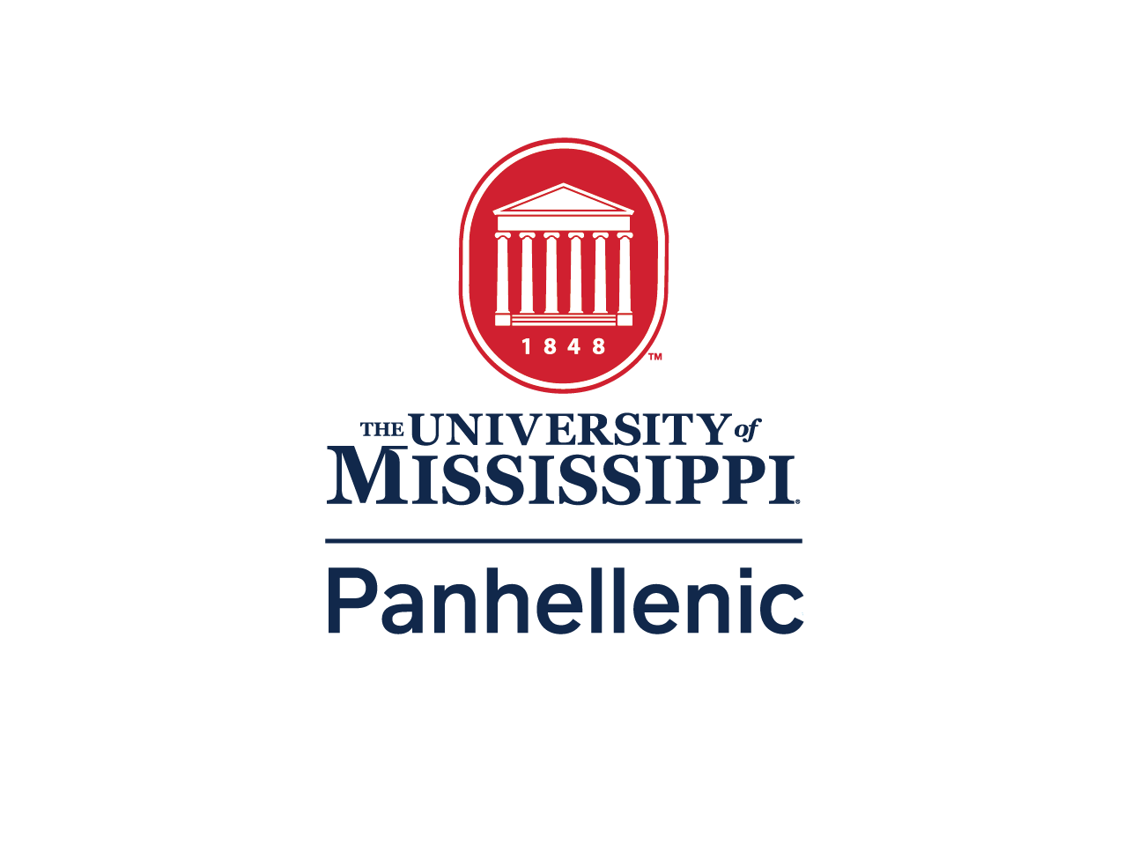

The University of Mississippi College Panhellenic Council
2024
Recruitment Participant Expectations

Updated and Approved on 04.10.24
Panhellenic Executive Officer Expectations
- Summer Orientation
  - College Panhellenic, in cooperation with Fraternity and Sorority Life, will sponsor FSL information sessions/tables during the summer orientations to promote FSL, and not individual organizations.
  - As Registered Student Organizations at the University of Mississippi, chapters may table individually at orientation sessions, if they choose. College Panhellenic will not provide any materials or resources for an individual chapter participating in these opportunities.
- Panhellenic Executive Board
  - No Panhellenic Officer shall sit in on chapter recruitment meetings or workshops.
  - Panhellenic Officers shall not wear or carry any item indicating their sorority membership (i.e., t-shirts, insignia, car tags, etc.) beginning with Commencement and ending at the conclusion of Fall Panhellenic Primary Recruitment.
Panhellenic Standards Board Expectations
- A Panhellenic Standards Board Member cannot be stationed at their own chapter facility.
- Panhellenic Standards Board members will warn the Panhellenic Recruitment Chairman five minutes before the time for the total event to be over if the sorority has not begun to show signs of ending the event. Panhellenic Standards Board members will have their watches set at the same time and theirs will be the official time.
- For the duration of Fall Panhellenic Primary Recruitment only, members of the Panhellenic Standards Board shall be considered as Panhellenic Recruitment Counselors for the sole purpose of filing College Panhellenic Violation Report Forms. Panhellenic Standards Board members will have the same authority to file these reports as Panhellenic Recruitment Counselors, according to NPC guidelines. All authority to file College Panhellenic Violation Report Forms will end 30 days following the conclusion of Fall Panhellenic Primary Recruitment, at which point, only Panhellenic Recruitment Counselors will be able to file College Panhellenic Violation Report
Forms under the title of “Panhellenic Recruitment Counselors.”
- Panhellenic Standards Board Members will be expected to follow all Panhellenic Recruitment Rules and the Panhellenic Standards Board Contract, signed at the beginning of their term. This is a separate document.
Panhellenic Recruitment Counselor Expectations
- No Panhellenic Recruitment Counselor may visit the inside of any house during Fall Panhellenic Primary Recruitment unless she is going to the restroom.
- Panhellenic Recruitment Counselors shall not wear or carry any item indicating their sorority membership (i.e., t-shirts, insignia, car tags, etc.) beginning on the last day of the spring semester (Commencement) and ending at the conclusion of Fall Panhellenic Primary Recruitment.
- Panhellenic Recruitment Counselors will be expected to follow all Panhellenic Recruitment Rules and the Panhellenic Recruitment Counselor Contract, signed at the beginning of their term. This is a separate document.
- Panhellenic Recruitment Counselors will be expected to adhere to the Strike Policy, signed at the beginning of their term. This is a separate document.
- Recruitment counselors should be available to PNMs at all times, and therefore, they will:
  - List times available for coaching at the Panhellenic office.
  - List phone numbers where they can be reached.
  - Schedule coaching group meetings.
  - Respond to calls in a timely manner.
  - Use email, texts, and social media only to arrange meetings or send other clerical messages.
  - The recruitment counselor should plan for regular meetings with her assigned potential new member group.
  - Agendas should cover:
  - Get-acquainted activities.
  - Explanation of the membership recruitment schedule, rules, procedures and the membership recruitment acceptance binding agreement (MRABA).
  - Thorough responses to all questions asked.
  - Scheduling of future meetings.
  - The recruitment counselors and Panhellenic officers are required to abstain from alcohol use prior to and throughout the recruitment process. Exact dates should be part of the College Panhellenic recruitment guidelines.
- Recruitment counselors maintain principles of Panhellenic ethics; therefore, they:
  - Are entrusted with privileged information to be kept confidential.
  - Must remain objective and impartial at all times.
  - Must refrain from the use of alcohol during the recruitment process.
  - May escort women to the events but not attend recruitment events.
  - Chapter Recruitment Events Policy (1989, 2022): Membership recruitment counselors and other designated Panhellenic personnel must not be present at chapter membership recruitment events held in either physical or virtual spaces. The exception to this is the permitted presence of fraternity/sorority advisors and official NPC recruitment observers.
  - Counselors Policy (2010): Recruitment counselors shall not be involved with any potential new members (PNMs) in the process of completing and signing the membership recruitment acceptance binding agreement (MRABA)
Potential New Member Expectations
- Potential New Members are defined as:
  - High school students
  - Students who are currently matriculating to The University of Mississippi and registered for College Panhellenic Primary Recruitment.
- Potential New Member (PNM) Eligibility:
  - A woman is eligible to participate in Panhellenic Primary Recruitment and join a Panhellenic chapter if she is enrolled at the University of Mississippi and not simultaneously enrolled in high school and attending college.
  - A woman is only eligible to participate in Panhellenic Primary Recruitment if she has not been an initiated member of any of the National Panhellenic Conference member organizations.
- If a woman completes the Panhellenic Primary Recruitment process and signs a Membership Recruitment Acceptance Binding Agreement (MRABA) she must wait until the next Panhellenic Primary Recruitment process at the University of Mississippi to receive another bid from a Panhellenic organization.
- In order to continue to participate in the Panhellenic Primary Recruitment process, Potential New Members must:
  - sign and abide by the Potential New Member contract at Convocation
  - abide by the Potential New Member Code of Conduct.
  - Attend all recruitment related events (i.e., Convocation, Recruitment Counselor meetings,
chapter events)
  - attend all events to which they have received an invitation
  - maximize their options during Selections until they sign the MRABA after the conclusion of their last event on Preference Round.
- During Panhellenic Primary Recruitment, no Potential New Members shall visit a sorority house except during designated Panhellenic Primary Recruitment events.
a. The only exception(s) would be: if rain occurs, Potential New Members may be allowed to enter the sorority houses even if the events have not yet begun, or if a Potential New Member has to use the restroom, in which case she may only enter the house if escorted by a Panhellenic Standards Board member.
- If a Potential New Member must leave an event for any reason, a Panhellenic Standards Board member must escort her. Active sorority members are responsible for notifying the Panhellenic Standards Board if a Potential New Member must leave.
- Potential New Members found in violation of any of the recruitment rules and procedures will be subject to dismissal from the Panhellenic Primary Recruitment process.

