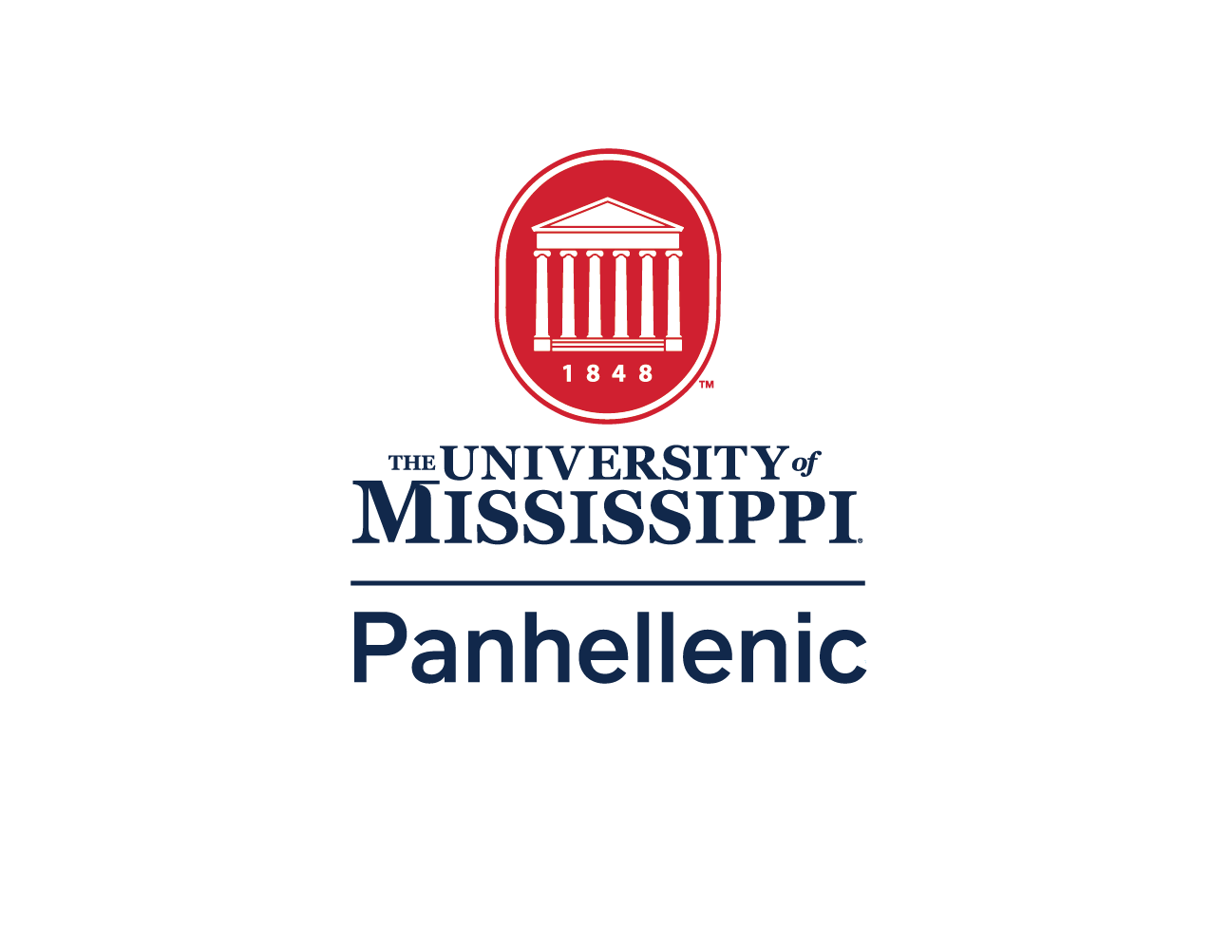
University Of Mississippi College Panhellenic Council

2024
Recruitment Contact Guidelines

Updated and Approved on 04.10.24

University Of Mississippi College Panhellenic Council 2024 Recruitment Contact Guidelines
All sorority women including collegians, alumnae, College Panhellenics, Alumnae Panhellenics, inter/national organizations and the National Panhellenic Conference should actively promote the overall sorority experience and membership opportunities in organizations. This should be done through all
forms of communication (e.g., print, digital, in-person) in the spirit of Panhellenic unity and desire to reach out to all women to share the opportunity for sorority membership. College and Alumnae
Panhellenic rules should not infringe on the rights of individuals, chapters and/or organizations in the content or forms of communication to promote the sorority experience.

Year-Round Contact Guidelines
These rules will be enforced by the College Panhellenic Council throughout the year. These are to be followed in addition to rules enforced within specific time frames prior to and following recruitment.
- NPC Unanimous Agreement VII. College Panhellenic Association Agreement 1.C. (2022): Each College Panhellenic Association shall prohibit the use of alcoholic beverages in membership recruitment and Bid Day activities.
a. This includes any form of membership recruitment including, but not limited to, Primary Panhellenic Recruitment and Continuous Open Bidding.
- Promotion of the Sorority Experience (2020, 2023)– POLICY: College and Alumnae Panhellenic rules must not infringe on the rights of NPC member organization chapters in how they communicate, contact and promote the overall sorority experience and membership opportunities to potential new members. All sorority promotion should be positive and in the spirit of Panhellenic unity through all forms of communication (e.g., print, digital, in-person).
- Any conversation between an affiliated member and a PNM must be uplifting to the panhellenic community as a whole and may not, under any circumstances, allude to the use of alcohol.
- If any representative of a chapter receives questions about Panhellenic recruitment procedures from a PNM or parents, they should be referred to Fraternity and Sorority Life (662-915-7609).
- Chapter websites shall accurately reflect all Panhellenic recruitment requirements.
- There are to be no gifts, favors, social purchases, cards, preference letters or notes given to the PNMs at any time.
  - All gifts received from PNMs to an NPC Organization are to be disposed of and reported to CPH.
- Chapter members should not bring PNMs to sorority/fraternity sponsored events, unofficial social gatherings with active members, and any event with the presence of alcohol. This includes, but is not limited to pre-games, fraternity events, events hosted/sponsored by alumni, mother/daughter teas, brunches, or equivalent in nature.
  - PNMs may attend philanthropy events as an exception to this rule.
  - If a PNM chooses to attend a philanthropy event, the PNM may purchase their ticket from an active member. No tickets should be given to a PNM. This is considered a gift.
- No Panhellenic chapter recruitment events, teas, brunches, dinners, and/or socials may be given, sponsored, or attended by active members, new members, alumnae and/or patronesses.
  - The only exception would involve an event hosted or sponsored by The University of Mississippi College Panhellenic. Should the College Panhellenic decide to host such an event, all Panhellenic sororities from the University of Mississippi will be given fourteen days (14) to ensure ample time and opportunity to attend the respective event.
- If a chapter member is seen buying/providing a drink for a PNM they will be called into an immediate mediation

Post Panhellenic Primary Recruitment Period: Day after Bid Day – First Day of Spring Semester
- High school women may not be invited to sorority chapter sponsored events. (or any other event involving alcohol)
  - PNMs may attend philanthropy events in the spring semester prior to recruitment.
  - If a PNM chooses to attend a philanthropy event, the PNM may purchase their ticket from an active member. No tickets should be given to a PNM. This is considered a gift.
- Chapters are not allowed to send holiday cards to PNMs (i.e., high school students).
- There will be no Panhellenic recruiting events or activities allowed with students who are not matriculated and/or taking classes at the University of Mississippi.
- No high school women or PNMs may attend a designated sorority date function or sorority/fraternity function during the academic school year, as designated by the University of Mississippi Academic calendar.
- Under the discretion and complete responsibility of said individual chapter, A PNM, as defined above, can be invited to a sorority house. The office of Fraternity and Sorority Life is not responsible for PNMs who are being hosted in said chapter’s facility or by members of said chapter in any capacity. This includes, but is not limited to, spending the night, or eating a meal.
- Under the discretion and complete responsibility of said individual chapter, A PNM, as defined above can be hosted by a chapter member overnight (including chapter houses, apartment complexes, or residential spaces).
- PNMs who attend the University of Mississippi may attend a fraternity function during the academic school year, as designated by the University of Mississippi Academic calendar.
- A family member, as defined above, may eat a meal at the sorority house. A family member, as defined above, may also spend the night at a sorority house during the aforementioned time.

Spring Semester Period: First Day of the Spring Semester – Day After May Commencement
- Any conversation between an affiliated member and a PNM must be uplifting to the panhellenic community as a whole and may not, under any circumstances, allude to the use of alcohol.
- There will be no Panhellenic Recruiting events or activities allowed with students who are not matriculated and/or taking classes at the University of Mississippi.
- Active sorority members may not bring PNMs to spring parties or other fraternity functions.
  - No high school women may attend a designated sorority date function or sorority/fraternity function during the academic school year.
- Under the discretion and complete responsibility of said individual chapter, A PNM, as defined above, can be invited to a sorority house. The office of Fraternity and Sorority Life is not responsible for PNMs who are being hosted in said chapter’s facility or by members of said chapter in any capacity. This includes, but is not limited to, spending the night, or eating a meal.
  - Under the discretion and complete responsibility of said individual chapter, A PNM, as defined above can be hosted by a chapter member overnight (including chapter houses, apartment complexes, or residential spaces).
- If a chapter member sees a PNM in a social setting, they are allowed to speak. These conversations must only be uplifting to the panhellenic community as a whole and may not, under any circumstances, allude to the use of alcohol. A chapter member may not provide a PNM with any form of alcohol.

Summer Period: May Commencement – August 7th, 2024
- No packets with PNM contact information, including, but not limited to pictures, will be given, mailed, e-mailed, or distributed in any print or electronic form to any member of an NPC organization that is not part of the exclusive Panhellenic recruitment team of each chapter, with the exception of sending alumni information from Campus Director to write a recommendation letter.

Pre-Recruitment Period: August 8th-14th, 2024
- Contact with PNMs prior to Panhellenic Primary Recruitment is encouraged only for the purpose of transmitting information about the Fraternity and Sorority Life Community as a whole, through Positive Panhellenic Contact.
- Chapters may not hold philanthropy events prior to recruitment.
- Sorority women may not seek out potential new members. If approached by a potential new member, sorority women are to promote Fraternity and Sorority Life, as well as Panhellenic membership in a positive light, not to recruit for a specific sorority. There should be no persuading by a sorority or individual sorority member.
a. If a chapter member sees a PNM in a social setting, they are allowed to speak. These conversations must only be uplifting to the panhellenic community as a whole and may not, under any circumstances, allude to the use of alcohol. A chapter member may not provide a PNM with any form of alcohol.

Fall Panhellenic Recruitment Contact Guidelines-August 15th-23th, 2024
- Beginning on the first day of Panhellenic Primary Recruitment until Bid distribution, a strict silence period will be enforced. Silence is defined as any verbal, nonverbal, written, printed, text message, and electronic communication or communication through a third party about
Panhellenic sorority recruitment. During this Panhellenic Primary Recruitment silence period:
  - No active sorority member, including alumnae and new members, may communicate about the Panhellenic Recruitment process or live with PNMs unless approved by the Panhellenic Advisor or Panhellenic Vice President of Recruitment.
i. To prevent sanctions, each chapter will submit a list of PNMs that live with collegiate active members by the date set in the master Panhellenic recruitment schedule.
  - If PNMs live in the same space as an active or active collegiate member(s) (e.g., residence halls, apartments, etc.) or share academic courses, only casual greetings and contact are permitted. No discussion of a PNMs’ Panhellenic recruitment experience is permitted.
- Chapters may not have displays, banners, decorations, signs, etc. present on the lawn of the chapter facility during Panhellenic Primary Recruitment Week (e.g., campaign signs, etc.)
- Active members will not slander other chapters to a PNM nor inquire about and/or discuss another sorority’s Panhellenic recruitment Events or procedures at any time.
- Active members may not inquire about a PNM’s round schedule or legacy status at any time.
- If a chapter member sees a PNM in a social setting, they are allowed to speak. These conversations must only be uplifting to the panhellenic community as a whole and may not, under any circumstances, allude to the use of alcohol. A chapter member may not provide a PNM with any form of alcohol.

